Vele Tosevski

1002174657

CSC 411

March 27, 2019

**HW6 Write-Up**

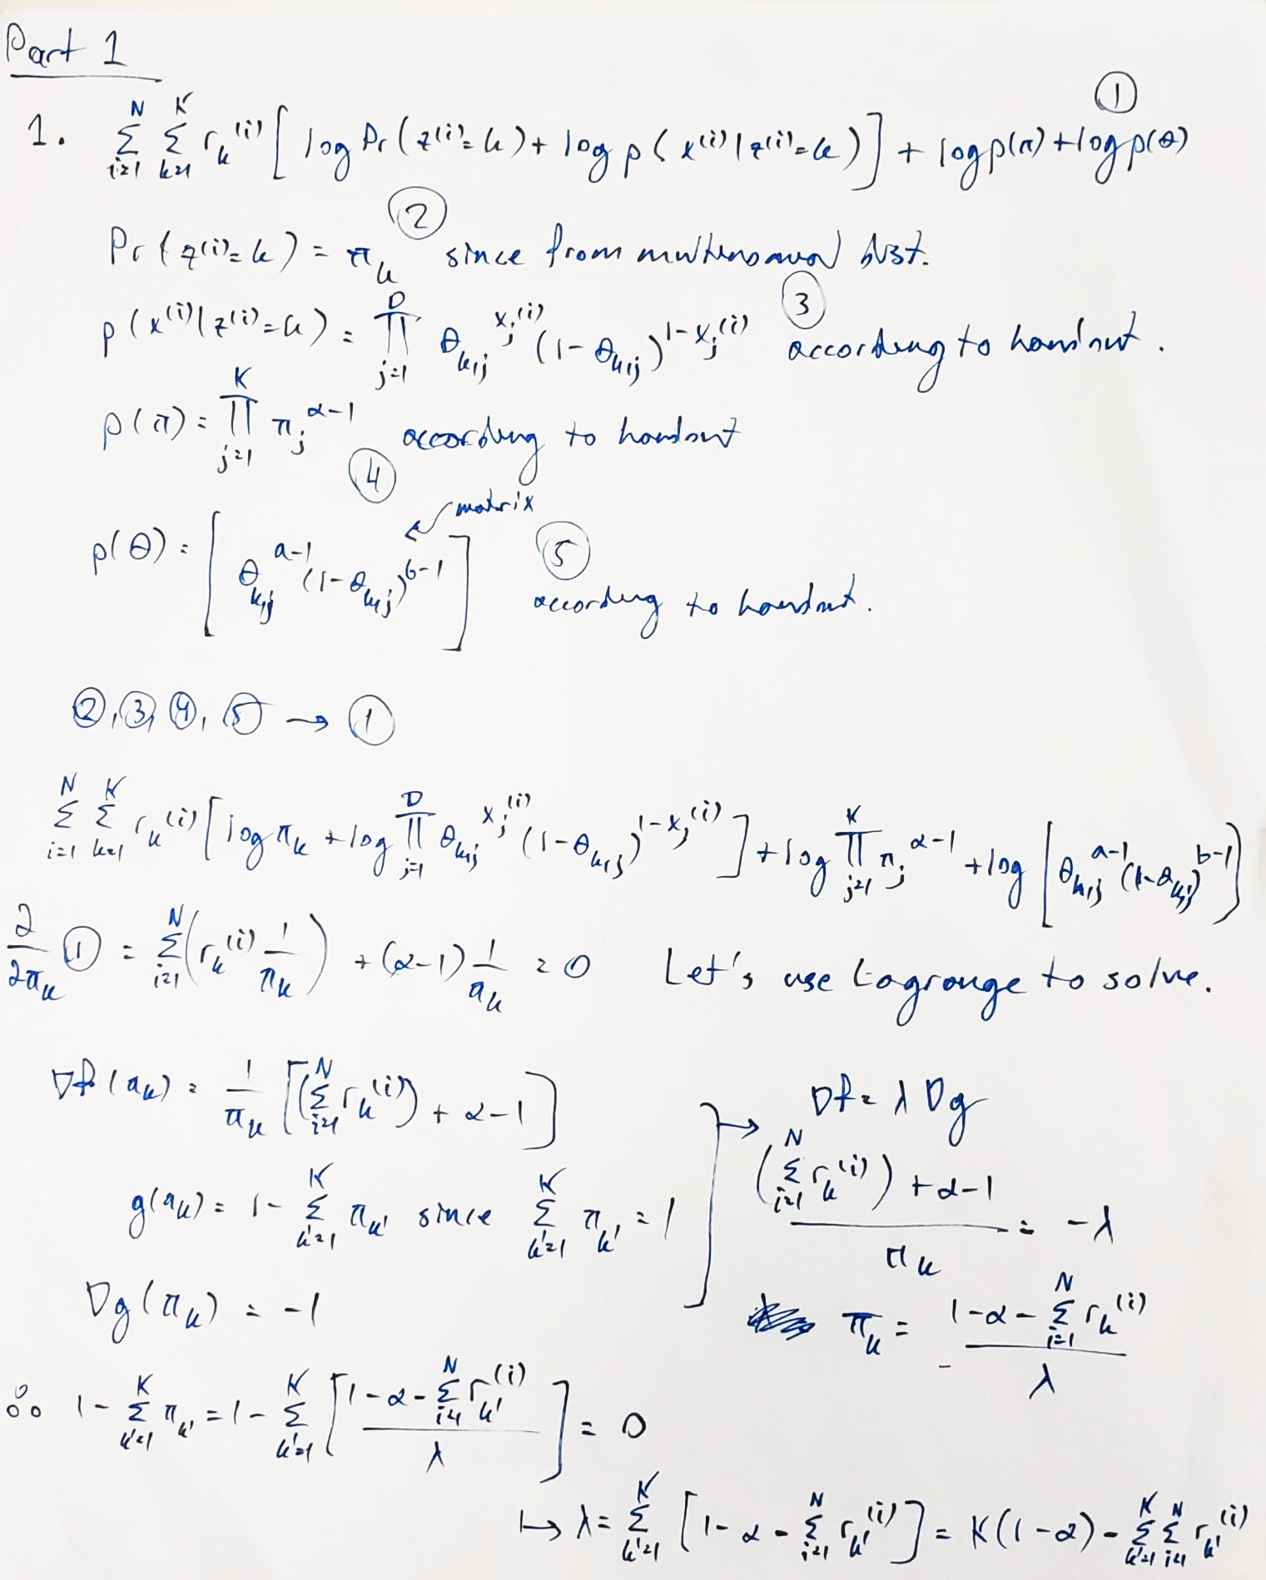

****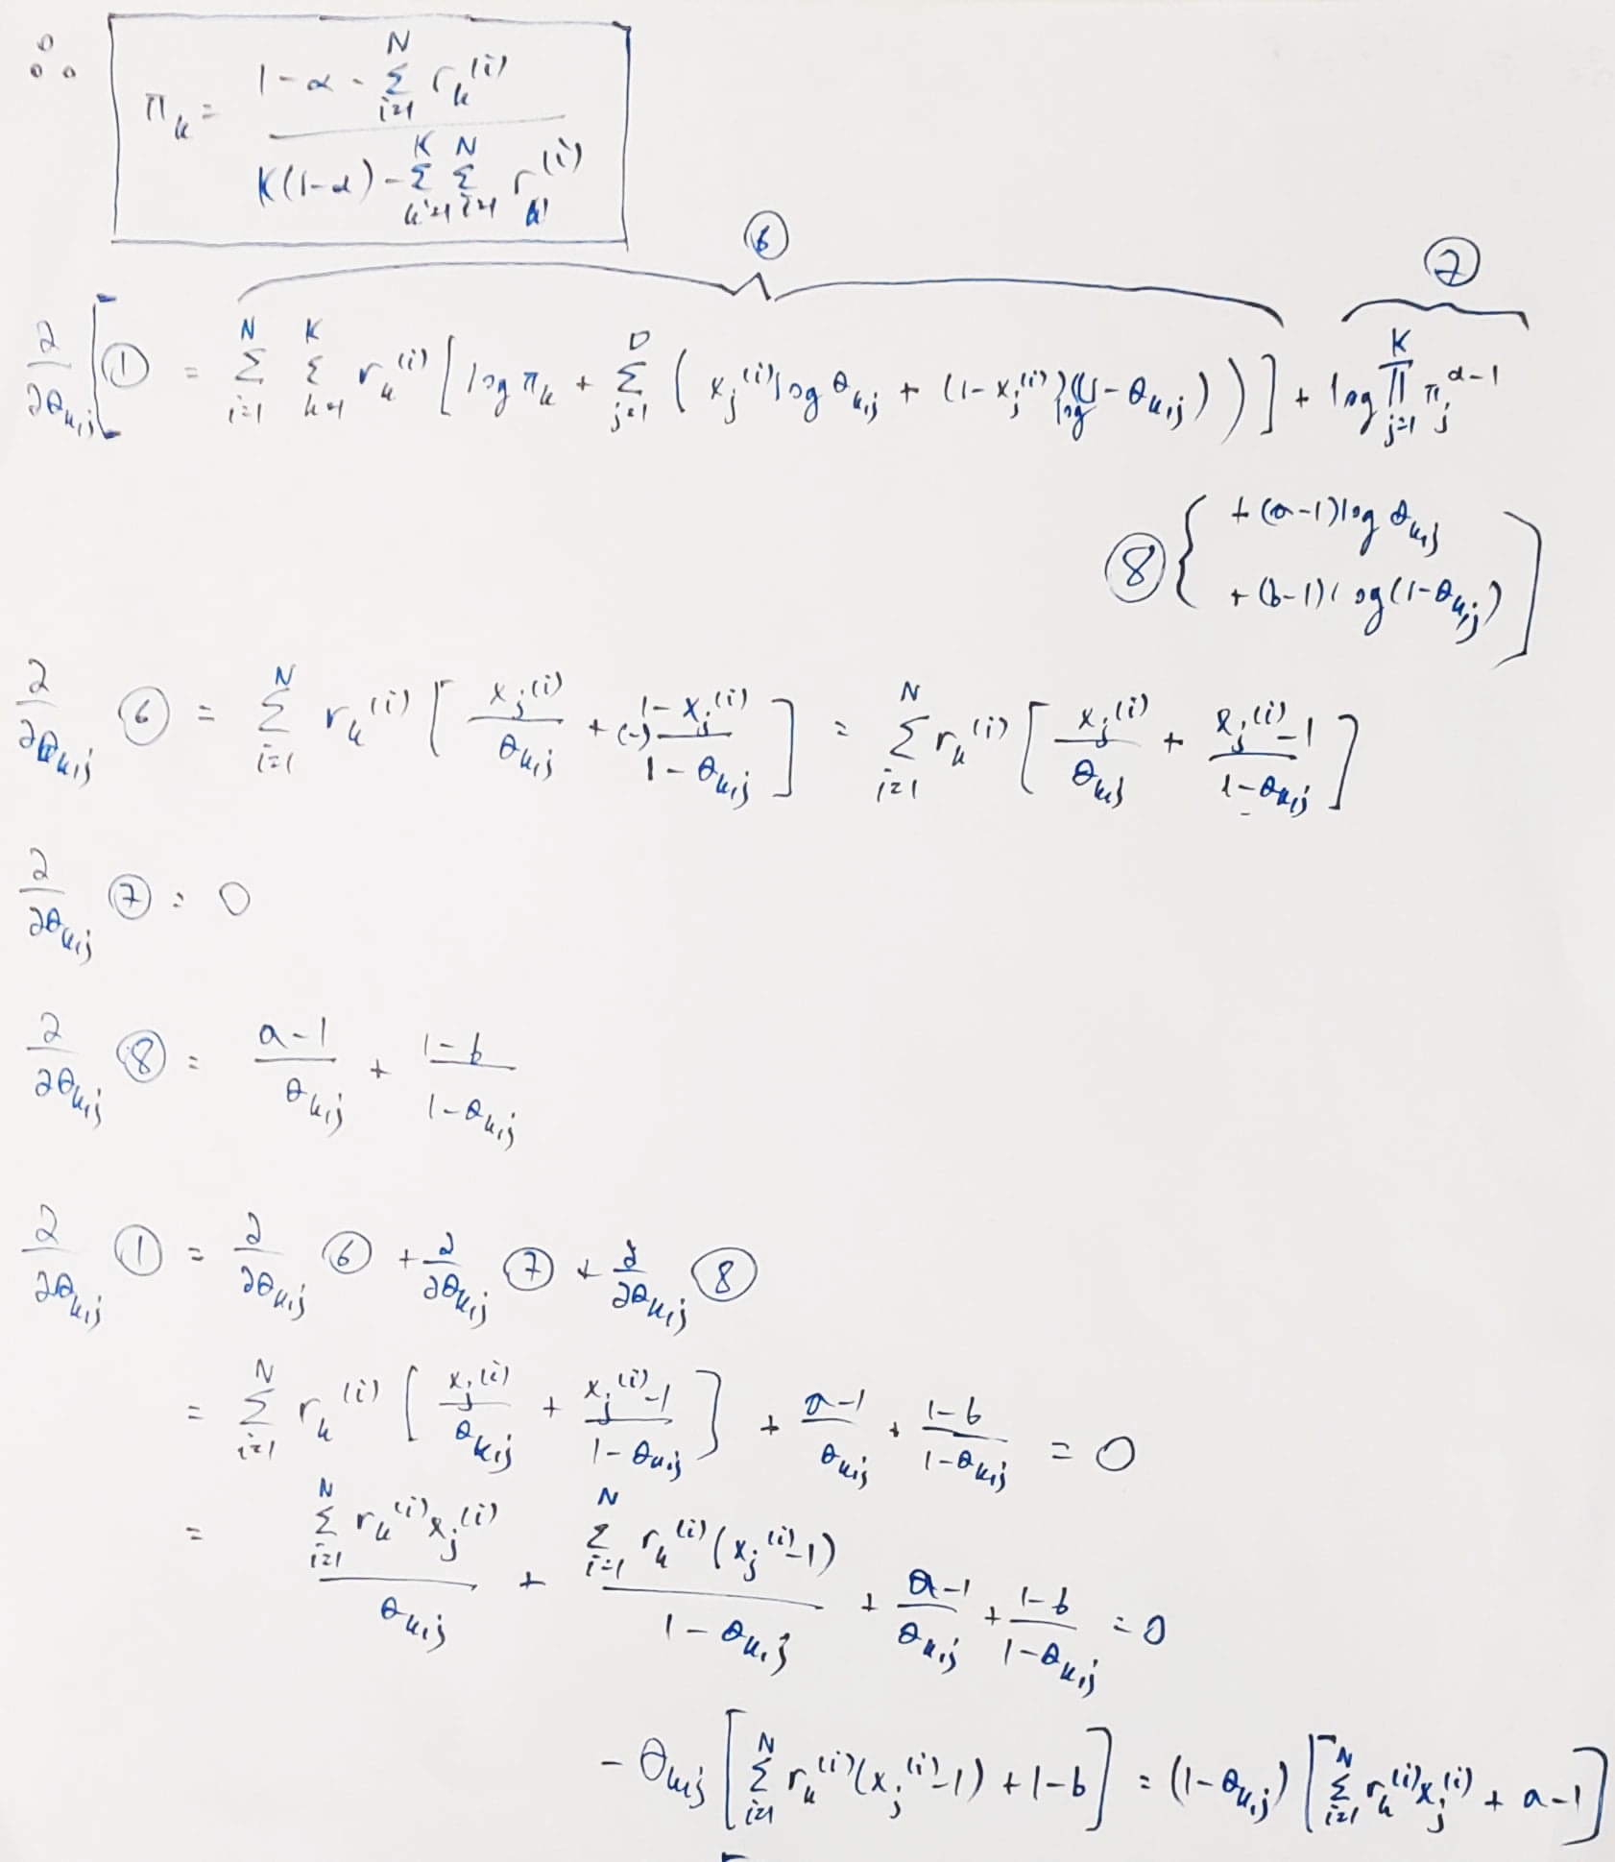



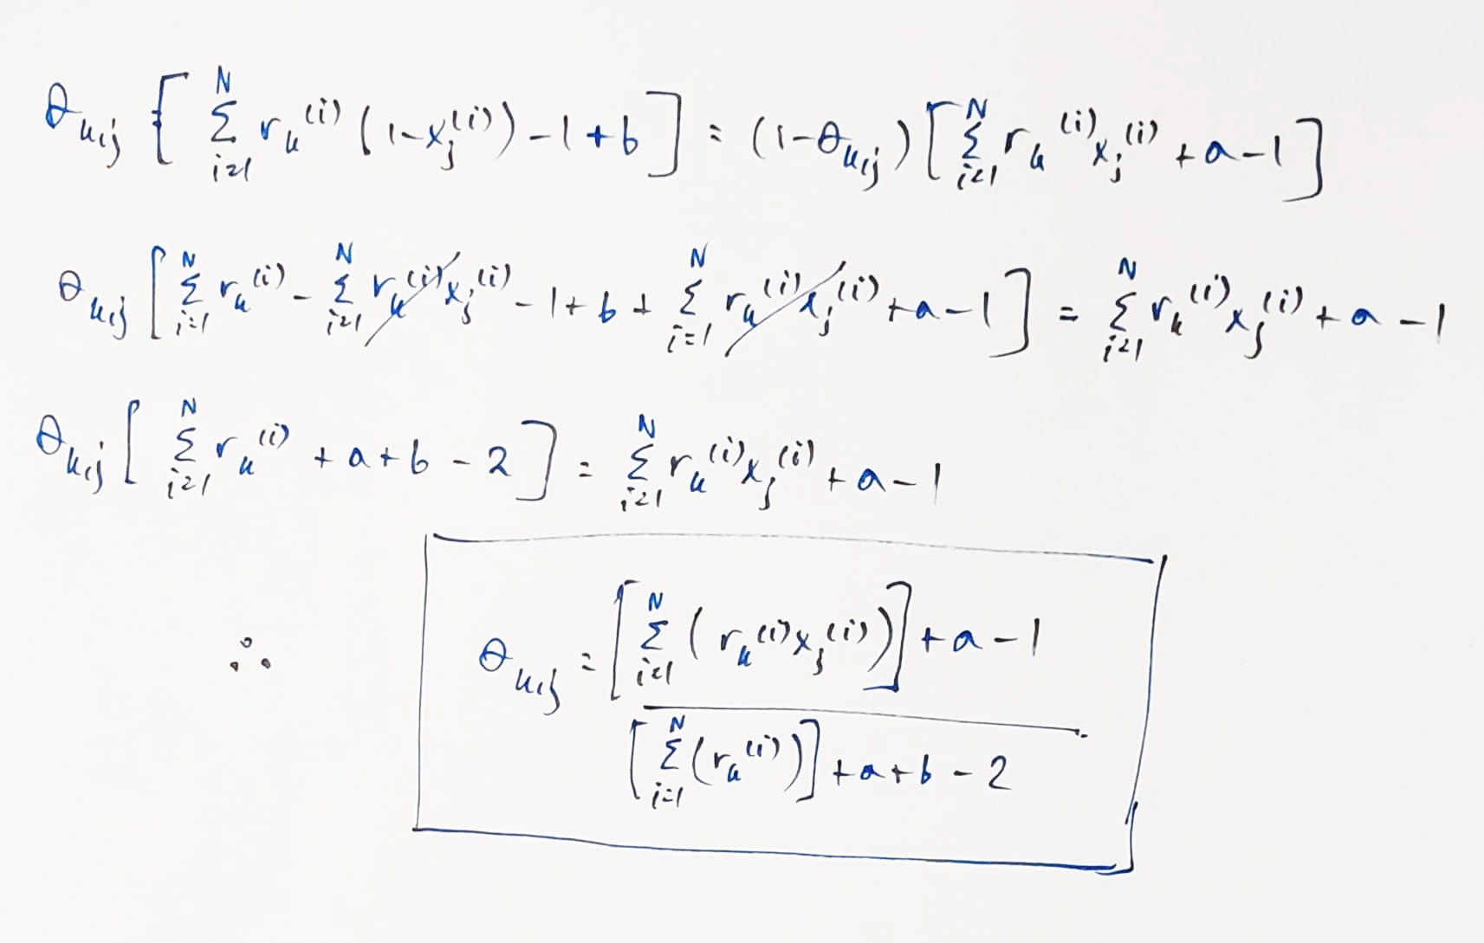

2.

Code in mixture.py

Part 1 output →

pi[0] 0.085

pi[1] 0.13

theta[0, 239] 0.6427106227106232

theta[3, 298] 0.46573612495845823

The theta update seems OK.

The pi update seems OK.

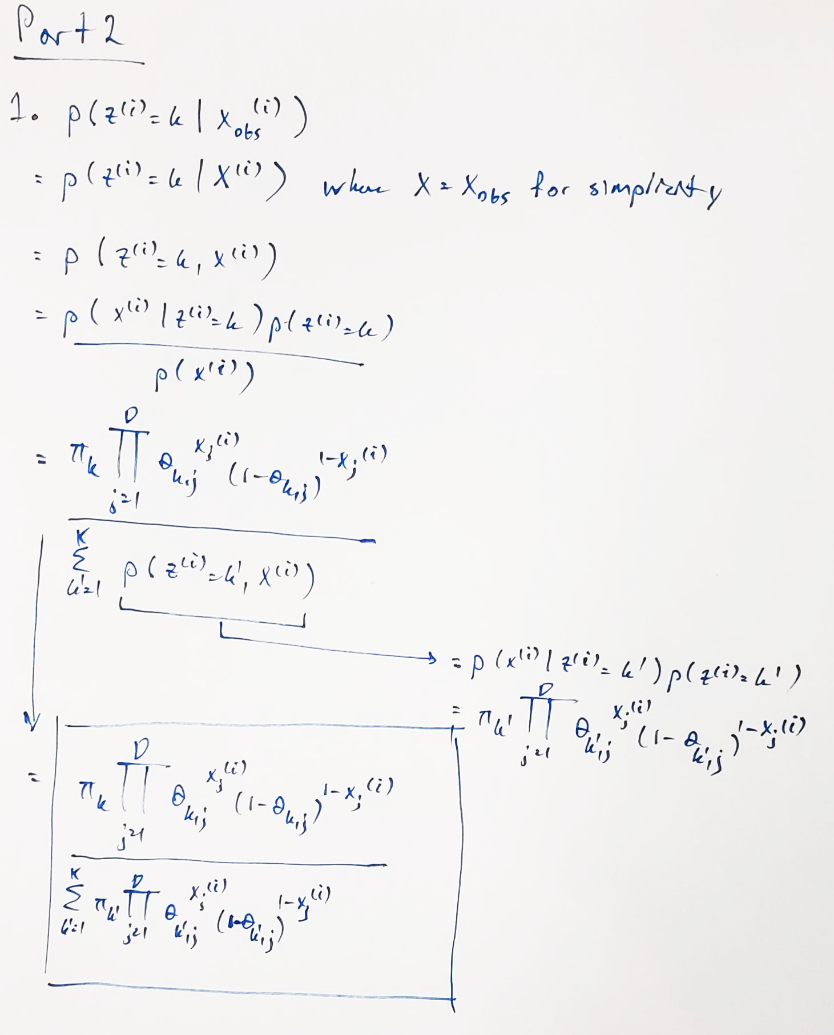

2. In mixture.py

3. In mixture.py

Part 2 output →

R[0, 2] 0.17488951492117286

R[1, 0] 0.6885376761092291

P[0, 183] 0.6516151998131036

P[2, 628] 0.4740801724913303

The E-step seems OK.

Part 3

1. Images that have not appeared in the training set often will be given a probability of zero. That is due to the nature of the normal distribution. If a certain pixel is always 0 in the training set then if it is 1 in the test set, due to the normal distribution, it will be assigned a probability of 0 and the M-step will not match it to a correct cluster.
2. The part 2 model has partial observations so intuitively, it should perform better at every step.
3. If you sample from the distribution, you will get 1 and 8 and equal amount of times since the distribution should be equally likely for both of them. The model is only saying that it is easier to pick a 1 than an 8, not that it is more likely, so the answer is no.